MINI PROJECT REPORT
Title: Secure Multi-Tier Web Application Network Architecture on AWS
Name: Gadamsetty Venkata Nagalakshmi Sanjana
Domain: Cloud and DevOps (July 2026 Batch)

Abstract
This project demonstrates deployment of a static website using Amazon EC2 and Apache HTTP Server, along with backup storage using Amazon S3. The objective is to understand basic cloud infrastructure, compute, storage, and security concepts through a practical implementation.

Objectives
• Launch an Amazon EC2 instance.
• Install and configure Apache HTTP Server.
• Host a static HTML webpage.
• Create an Amazon S3 bucket.
• Store the website backup in S3.
• Understand security groups and public IP access.

Tools & Services
AWS EC2, Amazon S3, Apache HTTP Server (httpd), Amazon Linux 2023, Web Browser, HTML.

Architecture
User Browser → Internet → EC2 Instance (Apache Web Server) → index.html
Backup: index.html → Amazon S3 Bucket

Implementation
1. Created an AWS account.
2. Launched a t3.micro Amazon Linux EC2 instance.
3. Configured Security Group with SSH (22) and HTTP (80).
4. Connected using EC2 Instance Connect.
5. Installed Apache using sudo dnf install httpd -y.
6. Started and enabled Apache.
7. Created index.html under /var/www/html.
8. Verified website using the EC2 public IP.
9. Created an S3 bucket.
10. Uploaded index.html as a backup.

Results
The static website was successfully hosted on Amazon EC2 and was accessible using the instance's public IPv4 address. A backup copy of the website was successfully stored in Amazon S3.

Advantages
• Highly scalable
• Reliable cloud hosting
• Easy backup and storage
• Pay-as-you-use model
• Suitable for web application deployment

Conclusion
The project successfully demonstrated the deployment of a static website on AWS using EC2 and Apache, with secure backup storage in Amazon S3. It provided practical exposure to core cloud computing services and basic infrastructure management.

Screenshots to Insert
Insert the following screenshots in this section with captions:
• EC2 Running Instance
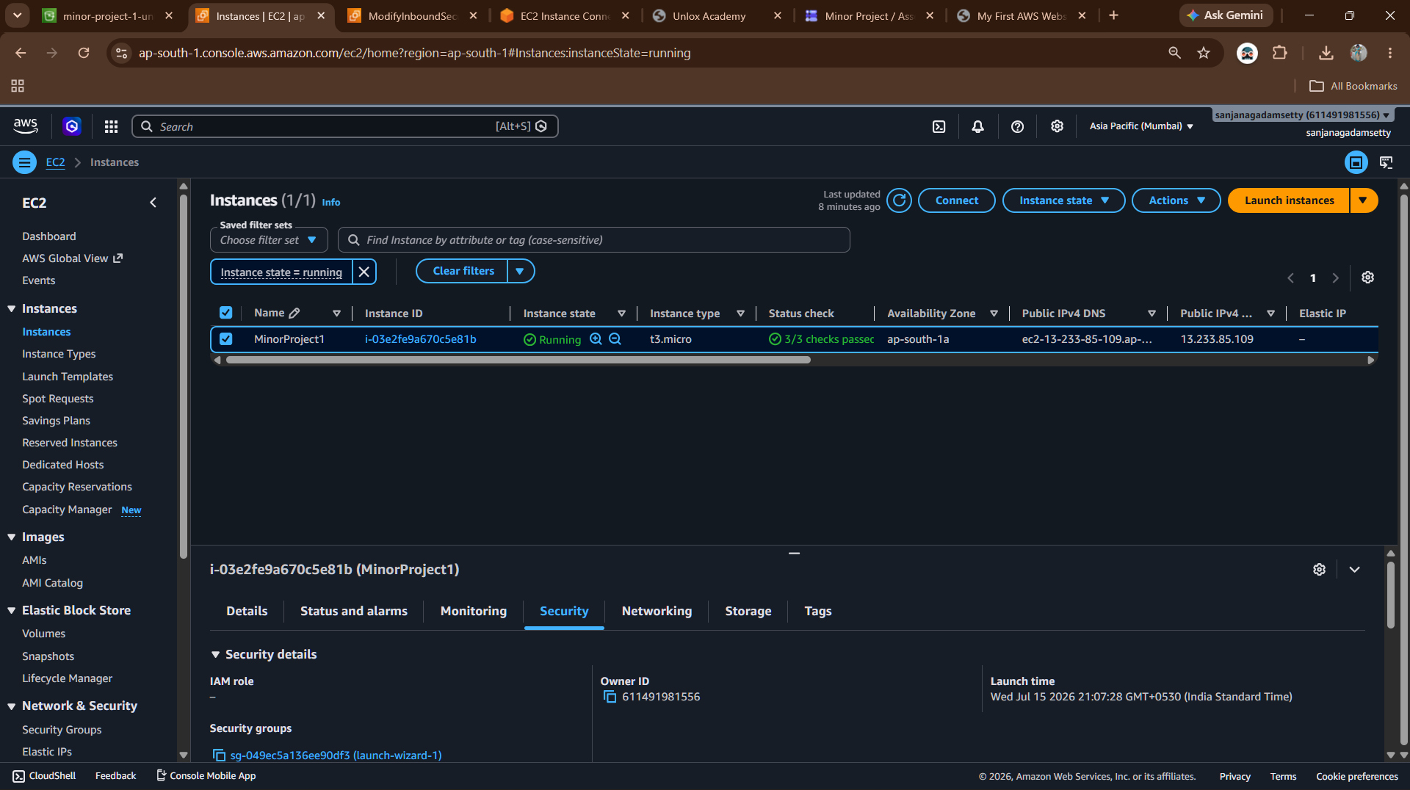
• Website Output
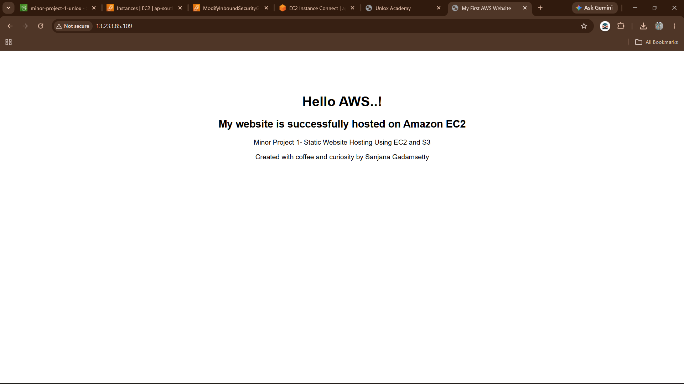
• Security Group (Ports 22 & 80)
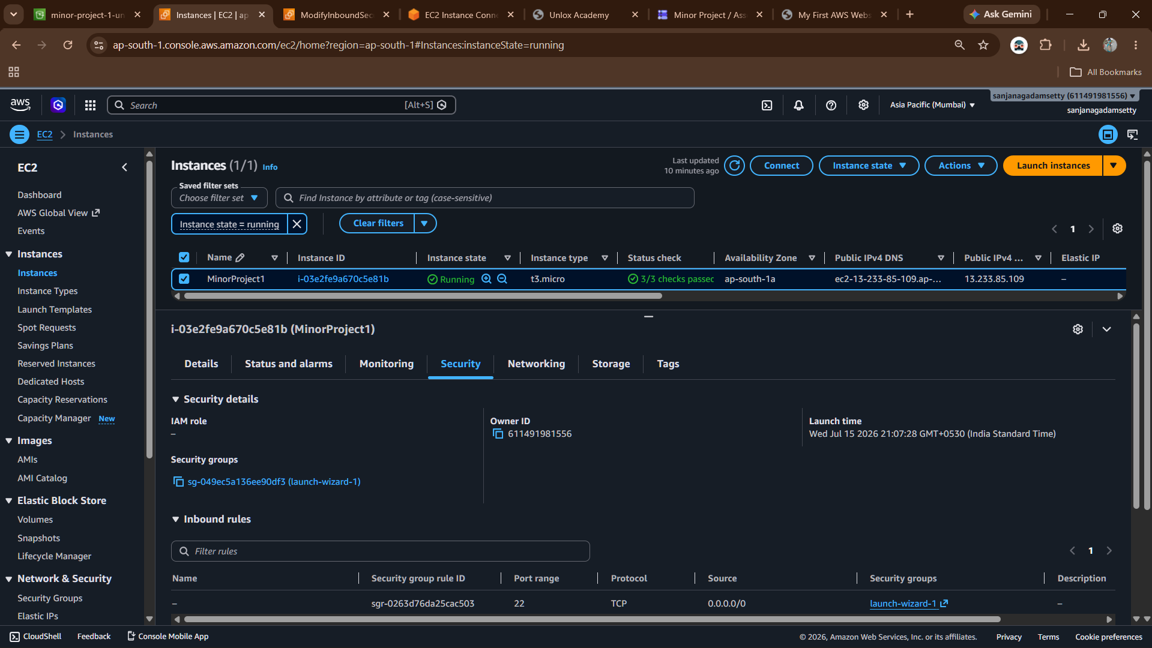
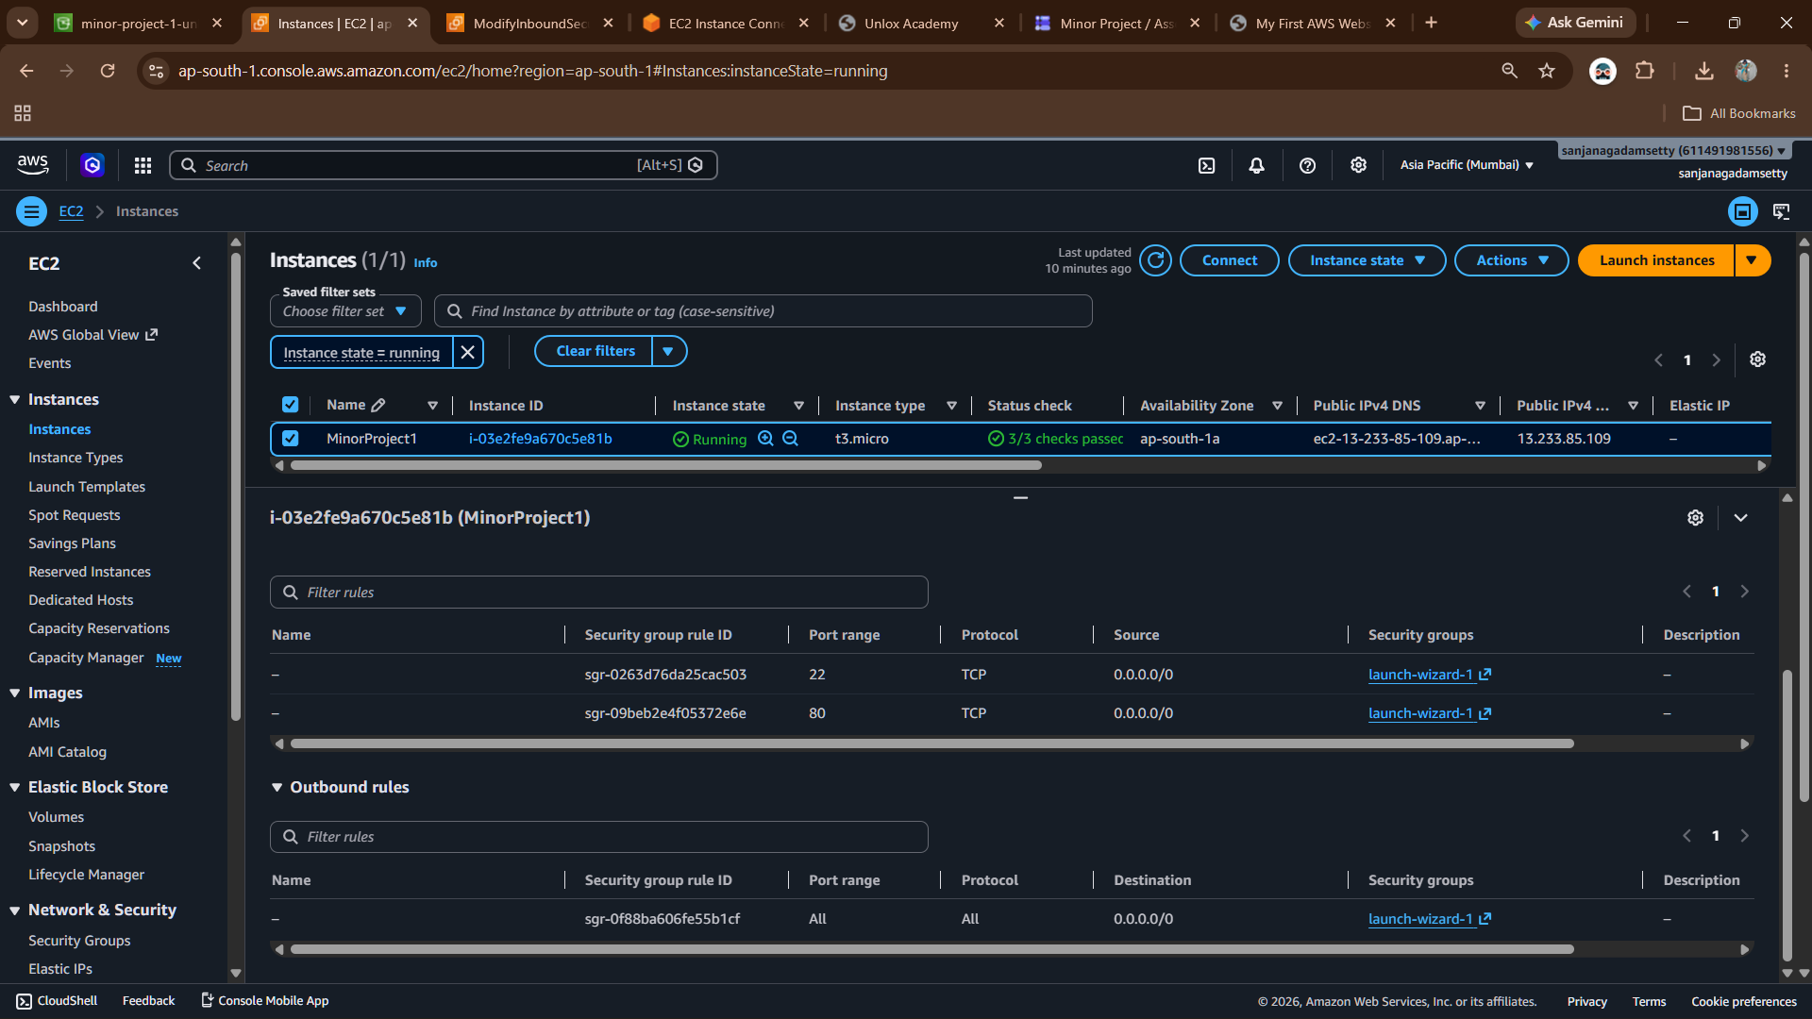

• S3 Bucket
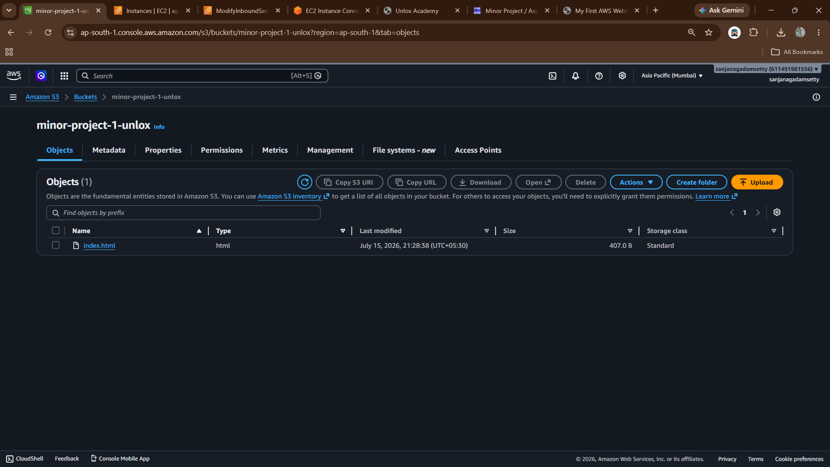
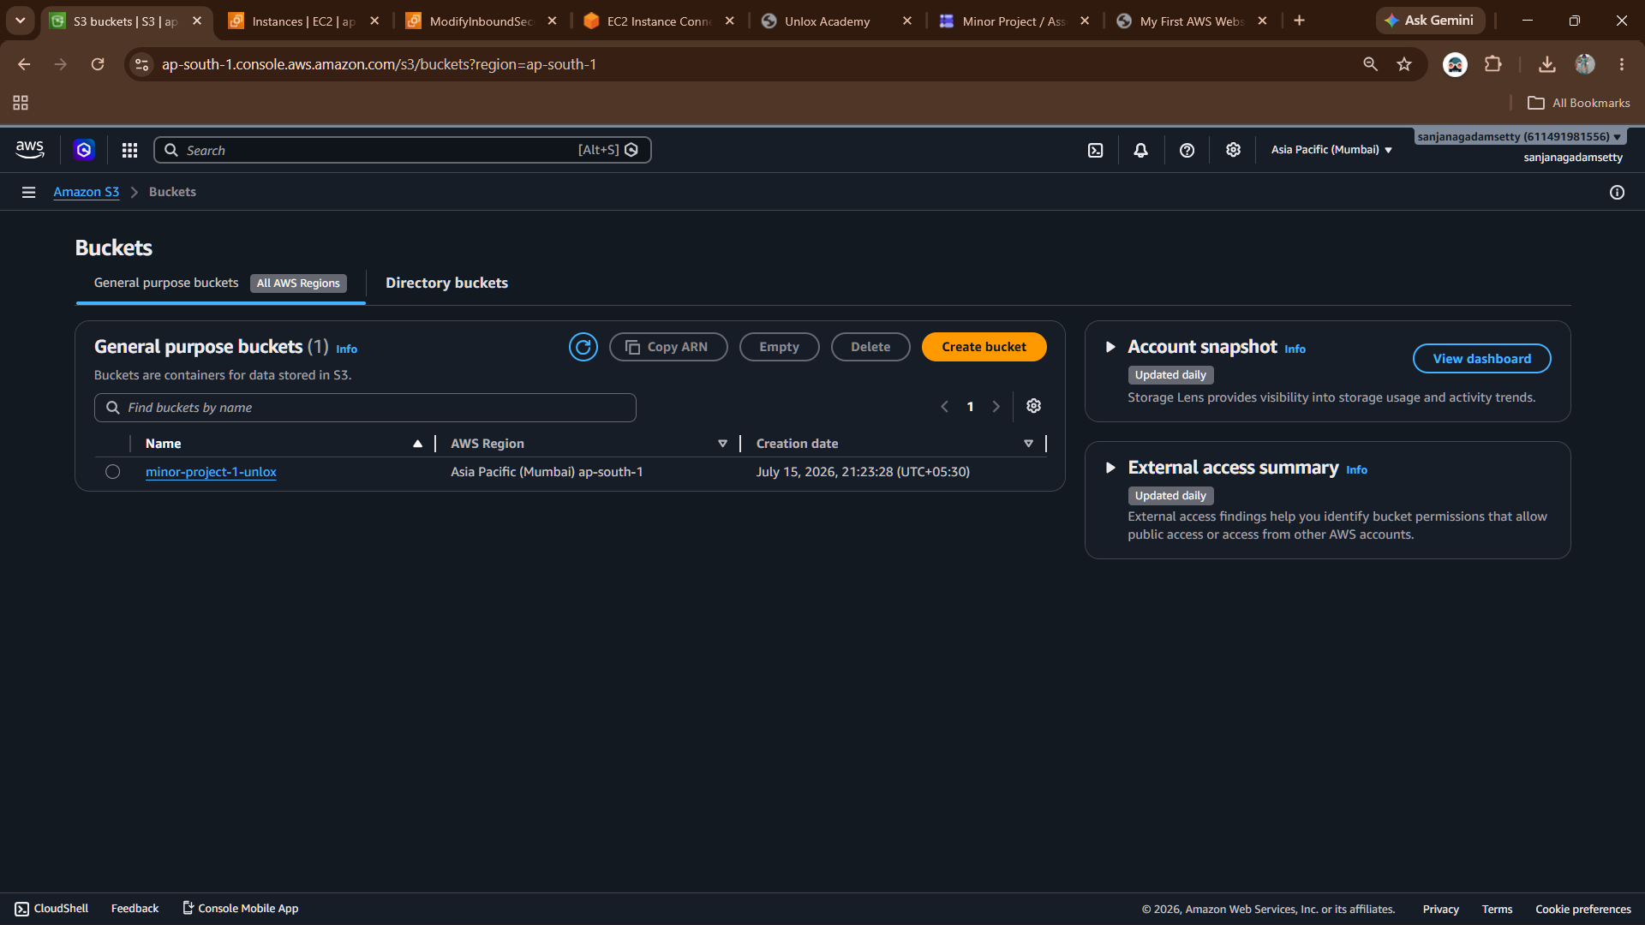
• Uploaded index.html
GitHub Link
https://github.com/SanjanaGadamsetty/UNLOX--Cloud-and-DevOps

